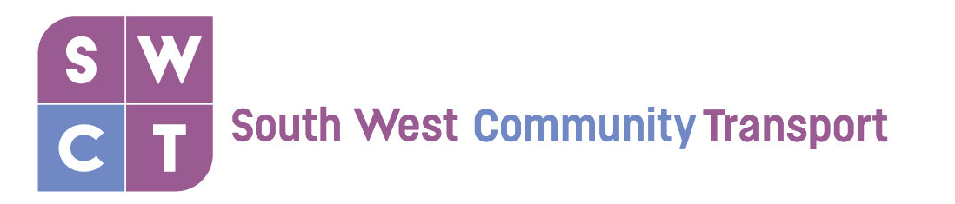
Funded by
Hoppa Shoppa Service: January – March 2020

Location | Date | Time at  Location | Price
The Forge Shopping Centre | Saturday 11th January | 10:00-16:00 | £6.00
Clydebank Shopping Centre | Saturday 18th January | 10:00-16:00 | £6.00
East Kilbride Shopping Centre | Saturday 25th January | 10:00-16:00 | £6.00
The Forge Shopping Centre | Saturday 1st February | 10:00-16:00 | £6.00
McArthur Glen, Livingston | Saturday 8th February | 10:00-16:00 | £10.00
Greenock | Saturday 15th February | 10:00-16:00 | £10.00
Irvine | Saturday 22nd February | 10:00-16:00 | £10.00
Clydebank Shopping Centre | Saturday 29th February | 10:00-16:00 | £6.00
The Forge Shopping Centre | Saturday 7th March | 10:00-16:00 | £6.00
Stirling | Saturday 14th March | 10:00-16:00 | £10.00
Largs | Saturday 21st March | 10:00-16:00 | £10.00
East Kilbride Shopping Centre | Saturday 28th March | 10:00-16:00 | £6.00

Please phone us on 0141 881 9998 to confirm your booking(s).

The bookings operate on a first come first served basis.

We require a minimum of 6 passengers for the trip to go ahead.

Trips are subject to cancellation due to weather conditions.

